**Experiment 3**

**Name : Sneha Savarkar UID: 2019120055 Branch : EXTC**

**Aim**: To apply F-test for hypothesis testing using SAS software.

**Dataset**:

The dataset I use was the SAS application's built-in car dataset. There are 428 rows and 15 columns in the dataset.

HO: mean horsepower of all the types of cars is same

Ha: mean horsepower of all the types of cars is different

**Code**:

PROC SQL;

CREATE TABLE WORK.query AS

SELECT Make , Model , 'Type'n , Origin , DriveTrain , MSRP , Invoice , EngineSize , Cylinders , Horsepower , MPG_City , MPG_Highway , Weight , Wheelbase , 'Length'n FROM SASHELP.CARS;

RUN;

QUIT;

PROC DATASETS NOLIST NODETAILS;

CONTENTS DATA=WORK.query OUT=WORK.details;

RUN;

PROC ANOVA DATA = WORK.query;

CLASS type;

MODEL Horsepower = type;

RUN;

PROC ANOVA DATA = WORK.query;

CLASS type;

MODEL horsepower = type;

MEANS type / tukey lines;

RUN;

PROC PRINT DATA=WORK.details;

RUN;

**Output**:

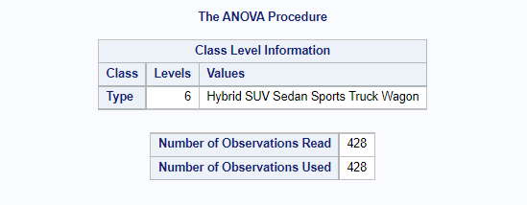

*Fig.1*

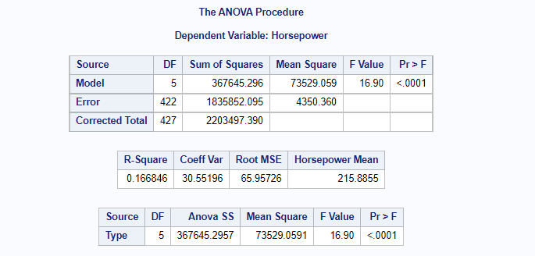

*Fig.2*

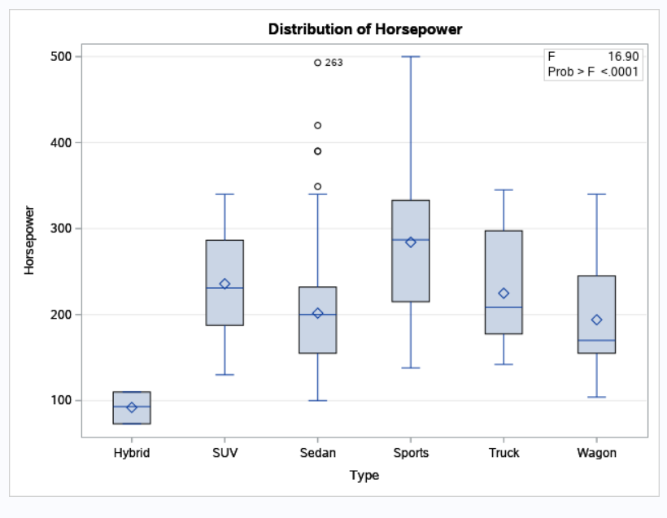

*Fig.3*

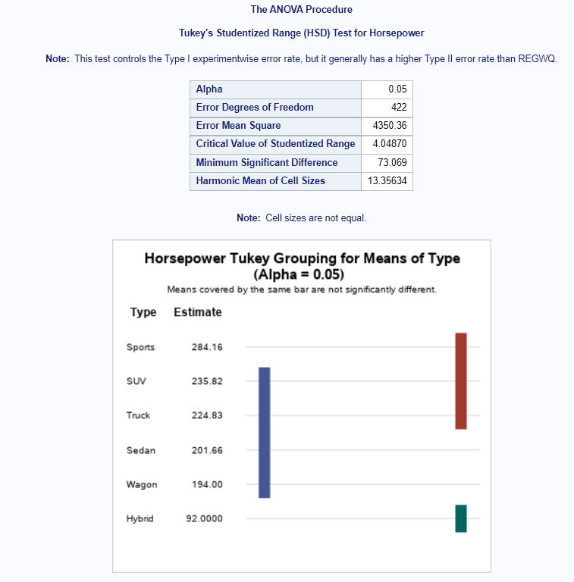

*Fig.4*

**Conclusion**:

From the above table the p-value from the f-value is  <0.001 indicating that the p-value is less than 0.01. As a result, we can conclude that our null hypothesis is invalid. That is to say, the mean of all car types is different.

We can back up this claim by looking at Fig. 4, which contains the entry 'Minimum significant difference.' This entry with the number 73.069 validates our conclusion.